KN95 Anti-Virus Face Mask 5 layer filtering protection

Details
100% brand new and high quality Dust-proof, Multi-layered protection, Germ and Virus protective Mouth-muffle Dust Mask. Non-woven fabrics and filtering material. These KN95 anti-virus mask will prevent foreign particles away from your respiration. 5 layer of filtering protection. FDA Approved. Only Blanks available.

COLORS AVAILABLE
White

IMPRINT COLORS
Not available

IMPRINT AREA AND METHOD
Not available

APPROXIMATE SIZE
7 x 6 x 2 inches ; 2.08 ounces in weight

PRODUCTION TIME
10-14 Day production time

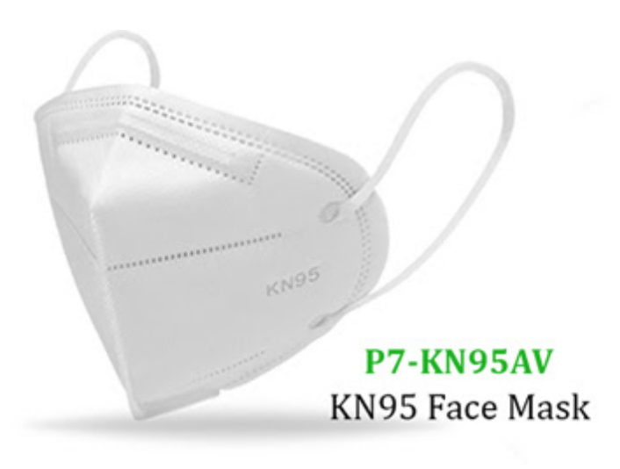

3 Layers Disposable Face Masks
This is an FDA certified disposable face mask designed for single-use wear. With 3 Layers of protection, it will keep out some harmful bacteria and give you peace of mind at home or while running errands.It is lightweight and comfortable, and its flexibility offers a comfortable wear for the duration of use

Main features:
– 3-Layer protection:
Wearing it could effectively block out dust, bacteria, droplets, and air pollution, and then offer oxygen for you to breathe comfortably, protecting your health.
– Breathable and comfortable:
Lightweight design, skin-friendly texture, wearing it even for a long time won’t create any fatigue or stress to your skin.
– Elastic earloop style:
Elastic earloop means that our mask could fit any face shape, which also helps you take on or off it quickly and easily.
– Built-in adjustable metal nose-bridge strip:
Built-in adjustable metal nose-bridge strip, just press it gently to fit the nose bridge to better seal your face.

COLORS AVAILABLE
Light Blue

APPROXIMATE SIZE
7.2 x 4 x 2.8 inches ; 0.16 ounces in weight

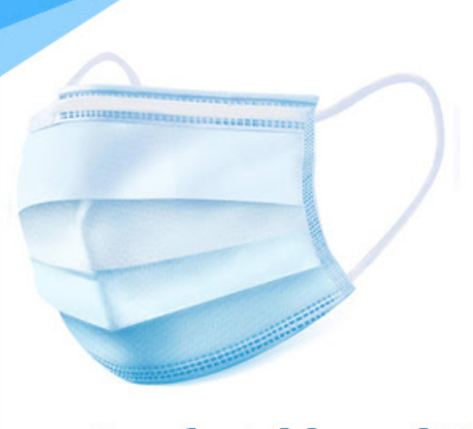

Powder-free Nitrile Gloves
Description:
Nitrile gloves have higher puncture resistance and more hypoallergenic compared to other gloves. These gloves conform to your hands for a more comfortable fit. Sold per box with 50 pairs of disposable, powder-free nitrile gloves. Comes in S, M, L and XL sizes.
For general public use
Lead Time (including shipping time):
Standard Service (business days): 12-19 days for up to 3000 boxes; 19-24 days for more than 3000 boxes
Rush Service (business days):
Product Detail:
Type: Powder-free Nitrile Gloves
Capacities:
Standard Colors:
Blue
Material: Nitrile
Standard Package: Box
Item Weight (g): 550

Hand Sanitizer with Alcohol, 2 oz.
Description:
Be protected against infectious agents wherever you go with this handy 2 oz. hand sanitizer. With 75% alcohol in clear gel. Packaged in plastic bottle with sticker on front where you can display your company's logo in full color.
Certificates: FDA/MSDS.
Price Includes:
- Free setup
- Free FCP on front sticker
Lead Time (including shipping time):
Standard Service (business days): 21-26 days (up to 30000 pcs); 8-30 days (>30000 pcs)
Rush Service (business days):
Product Detail:
Type: Hand Sanitizer with Alcohol, 2 oz.
Capacities:
Standard Colors:
Clear
Imprint Methods:
FCP
Imprint Location: Front
Imprint Size: 1.1 x 2.2 in.
MOQ: 1000
Item Dimension (inch): 1.77 x 1.06 x 3.50 in.
Item Shape:
Material: Sanitizer: Gel with 75% alcohol; Bottle: plastic
Standard Package:
Item Weight (g): 75
